# Instructions

The marketing team has requested a static IP address be configured on their Windows Server for network access.

They also anticipate the need for the following roles, role services, and features to be installed on the system:

* File and Storage Services Role
* File Server (Role Service)
* Web Server (IIS) Role
* IIS Management Console (Role Service)
* ASP.NET (Feature)

HINTS: You can reuse the network settings set by DHCP. For now, we are just installing the roles, services and features. We will configure them in the next assignment.

# Screenshots

Paste the required screen shots under each description.

1. Show a screen shot of the IPv4 Properties window showing the correct static settings.

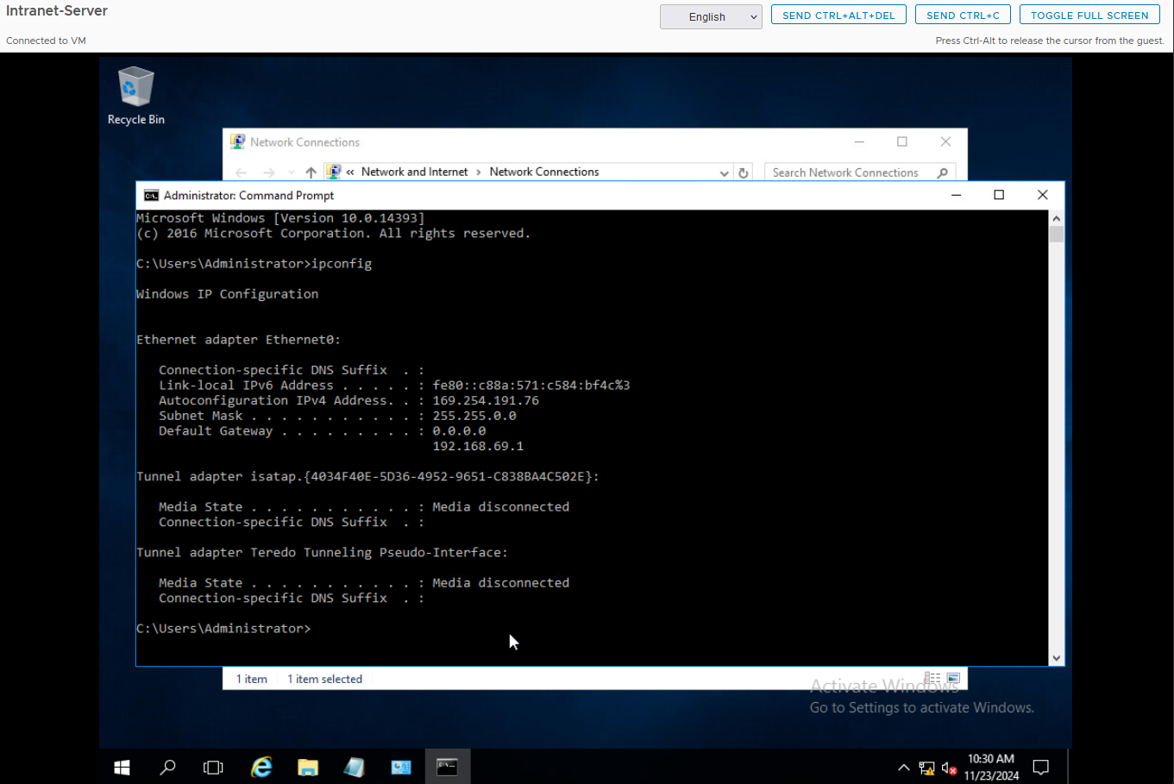

1. Show a screen shot of the “Roles and Features” under Local Server in Server Manager showing all of the new installed Roles, Services, and features.

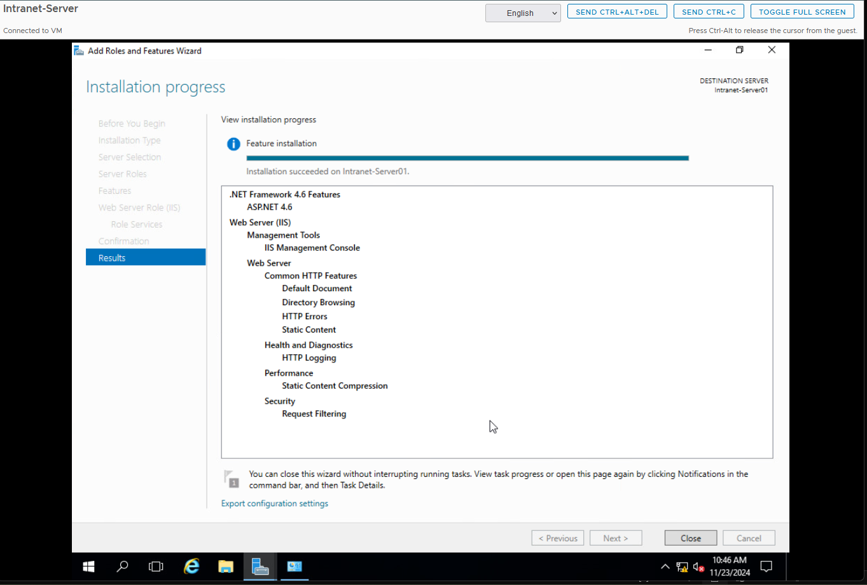

# Documentation

Record and explain all the steps you took to complete the task. Include any commands used, screen shots showing GUI interfaces, or any other information that would help you recreate the task.

**Note: You will be allowed to use this documentation to help you complete future assignments.**

Open Run and type ncpa.cpl, then press Enter to open Network Connections.

Right-click the active network adapter and select Properties.

Highlight Internet Protocol Version 4 (TCP/IPv4) and click Properties.

Set static IP settings:

IP Address: 192.168.69.211.

Subnet Mask: 255.255.255.0.

Default Gateway: 192.168.69.1.

Preferred DNS Server: 10.27.3.2.

Alternate DNS Server: 10.25.3.2.

Click OK to save changes.

Open Command Prompt and run ipconfig to verify the static IP is applied.

Opened Server Manager.

Click Manage then Add Roles and Features.

Selected Role-based or Feature-based Installation and click Next.

Choose your server in the Destination Server step and click Next.

Added the following roles and role services:

File and Storage Services to File Server.

Web Server (IIS) > IIS Management Console.

Added the following features:

ASP.NET.

Confirm the selections and click Install.